**Embroidery Name Drop Guide**

When a job requires a main logo and then an additional individual name below the main embroidery please follow these rules.

**Sales** will need to organize their excel documents by size.

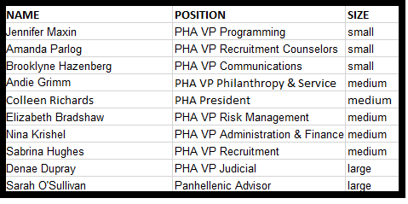

**Digitizing** will need to upload their DST files by size. In each file, we will have the logo as well as the individual names of that size category. The names will be stacked on top of each other in the DST with color changes and pauses built. Here is an example of all the Mediums stacked.

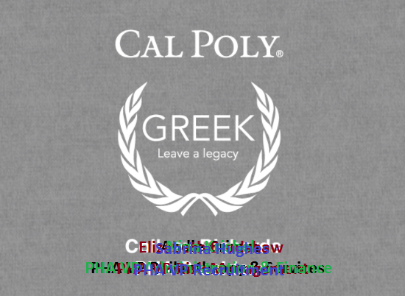

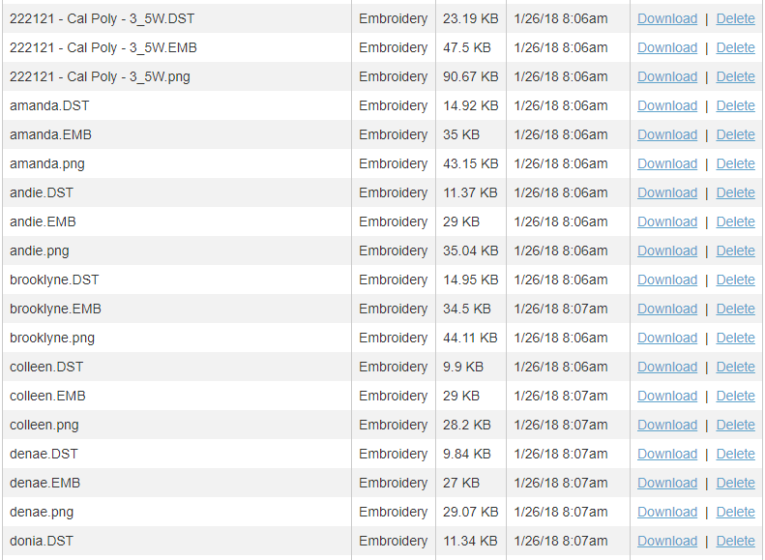

Instead of each name being uploaded, we will have clusters of sizes. For example in this order, the files would be: Small.dst, Medium.dst, and Large.dst

We would also need to limit the amount of names per file to 8 max at a time.

**Embroidery Operators** will be able to hoop 5 garments and run the 6 head to decorate all 5 at the same time. Then we will turn off all but 1 head, embroider the first name.

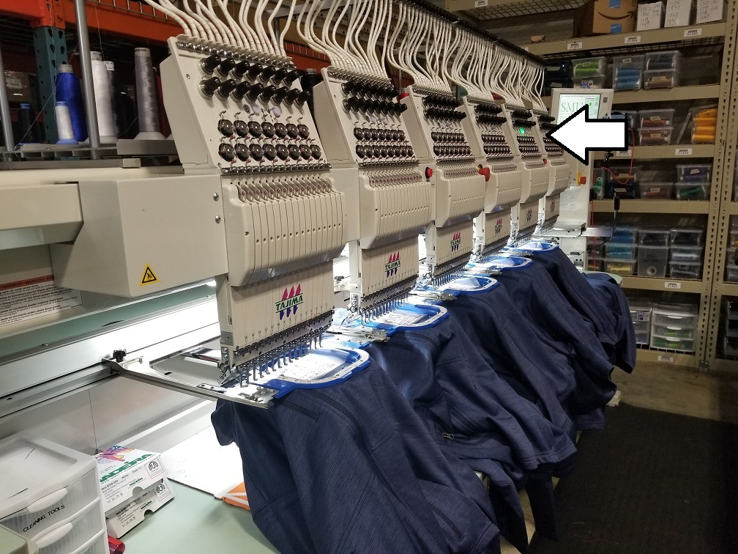

After Andie Grimm’s info is embroidered, the machine will pause and we will turn off all the heads except the next one down.

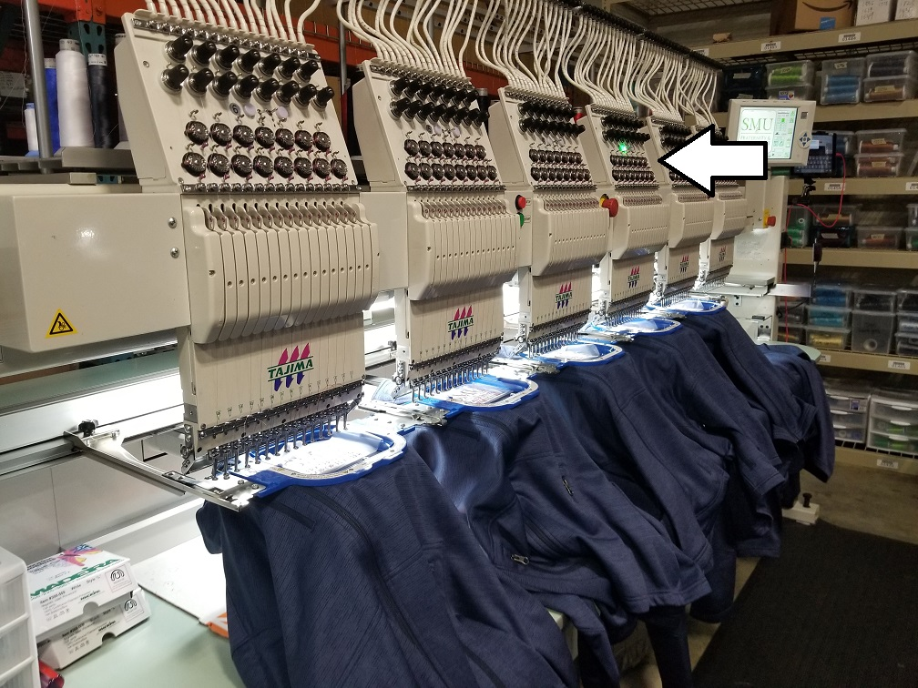

The machine will now embroider Colleen Richard’s info.

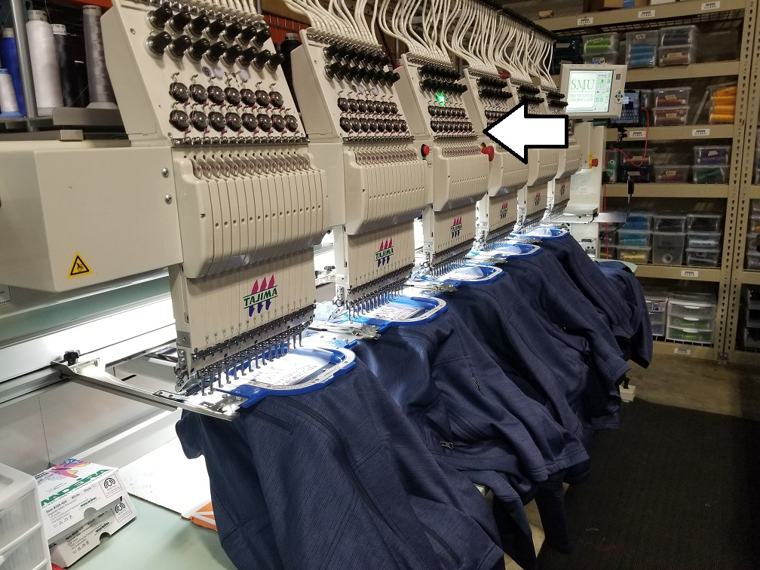

We make our way down the line, each medium garment getting the individual embroidery added in the same spacing and location as the rest.

By separating files by garment size, we can cycle through the names and garments at a more efficient pace with better consistency between garments.